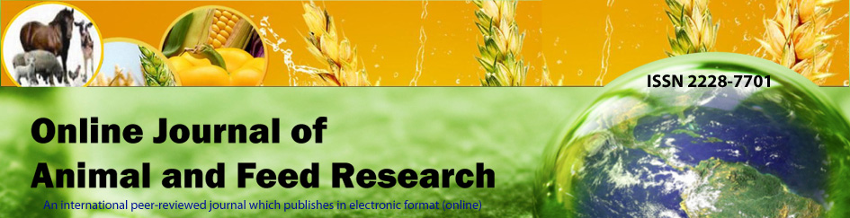
Scienceline Pub.
www.science-line.com

Online Journal of Animal and Feed Research
ISSN 2228-7701
www.ojafr.ir ; www.ojafr.com
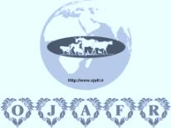
Signed copy must to be sent by mail to: editors@ojafr.ir

DECLARATION OF THE AUTHORS
All authors of the manuscript entitled:
............................................................................................................................................................................................................................................................................................................................................
intended for publication in the Online Journal of Animal and Feed Research declare that

- they agree to this publication after any amendments arising from the peer review.
- they agree to the posting of the full text of this work on the web page of the journal and to the inclusions of references in databases available on the internet.
- no results of other researchers were used in the submitted manuscript without their consent, proper citation or acknowledgement of their cooperation or material provided.
- the results (or any part of them) used in the manuscript have not been sent for publication to any other journal nor have they already been published (or if so, that the relevant works are cited in this manuscript).
- submission of the manuscript for publication was completed in accordance with the publishing regulations pertaining to their workplace.
- experiments performed comply with current laws and written consent of Scientific Ethnic Committee / National Animal Care Authority is available (as it is mentioned in the manuscript submitted).

AUTHORS OF THE MANUSCRIPT

E-mail name date signature

Updated in January, 2021
Available as PDF & WORD document at http://www.ojafr.ir/main

