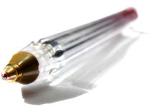

Application Form
(* items = necessary)

Place your photograph here
Your passport photograph or any better
INFO *
Full Name:
Gender:
Nationality:
Complete Postal Address:

Telephone No.: Mobile No.: Fax No.:
You must add country code, city code before your telephone, mobile and fax number
E-mail ID:
Alternate E-mail ID:
Your main field of specialization:
Rank your current area of expertise with maximum five keywords

Education *
Year Degree/Certificate Institute Attended Field of Study
.
.
.
.
.
.
.
PLEASE don’t use abbreviated institutional name

Career detail
Year Designation Institute
.
.
.
.

PLEASE don’t use abbreviated institutional name

LIST OF PUBLICATIONS *
.
.
.
.
.
.
.
.
.
.
.
.
.
.
.
.
.
.
.
.
.
.
.
Supporting letter * (max. 1000 words that outlines your experience and ability to perform the role.)

